Setup and Use of the Cisco UCS Platform Emulator
The UCS Platform Emulator provides the ability to configure virtual hardware which is then accessed via UCS Manager, which is the UCS platform’s management tool. This article provides an overview of how to use the UCS Platform Emulator step by step. Step 1 - Step 7 are used to configure UCSPE, and Step 8 - Step 10 are to configure UCSM.
Here is the original link of this document:
http://vmiss.net/2016/07/19/setup-and-use-of-the-cisco-ucs-platform-emulator/
Some minor changes are made based on it.
Step 1: Download Cisco UCSPE .ova image
Cisco link: https://communities.cisco.com/docs/DOC-37827
SH copy for UCSPE_3.1.2e: \\10.62.59.130\maglev\RackHD OVA
Step 2: Deploy OVA on ESXi
This article assumes you know how to deploy an OVA. However, if you encountered below issue when power on the deployed OVA:
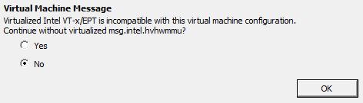
You should upgrade virtual hardware with the deployed OVA:
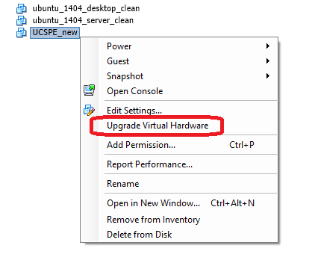
Step 3: Initial Setup of Emulator
Power on UCSPE, login with VMWare console. The default login password and username are: ucspe/ucspe
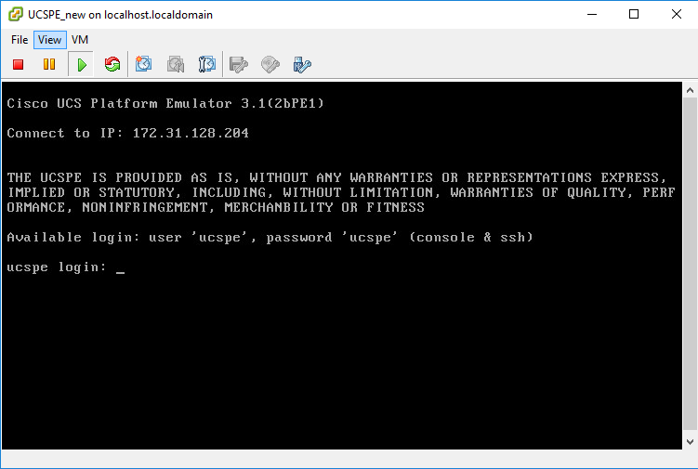
Here is the console after login:
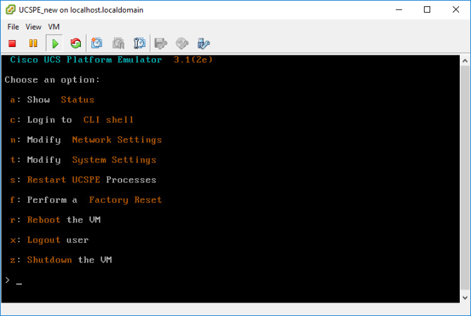
By default, the VM will use DHCP, but you can put in static IP addresses if you would like.
If you want to continue with DHCP, hit a to view your current IP address.
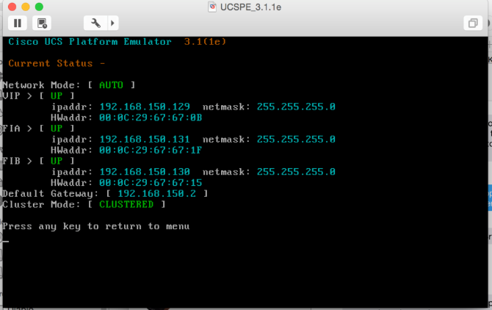

If you want to use a static address, hit n for modify network settings, enter y for confirmation and choose c to customize IPs.
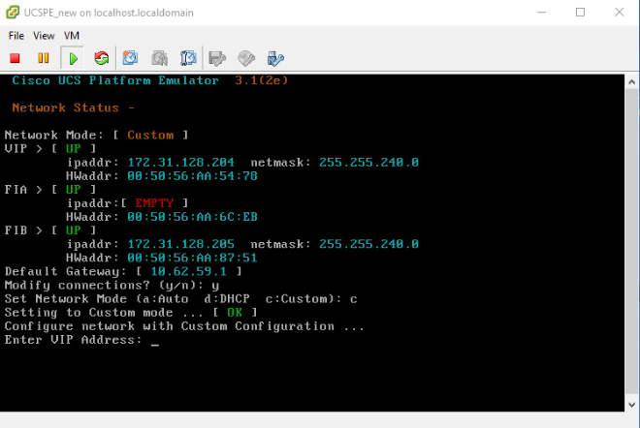
You need to configure all 3 NICs with static IP if you choose to use static IP.
Step 4 Logging into the UCS Platform Emulator
Navigate to the IP address of the VIP in a browser, and you will be greeted with the UCS Emulator interface. There are two main parts of the interface, the Equipment Inventory and UCS Manager. First, we are going to start with the equipment interface.
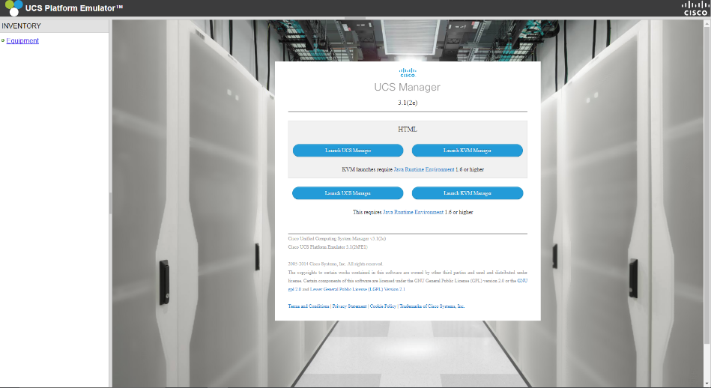

Step 5 Managing Equipment
Note: if you want to use default UCSPE devices configuration, you can skip step 5 and step 6.
The UCS Emulator comes with equipment already “installed”. Click Equipment in the Inventory pane on the left to get started.
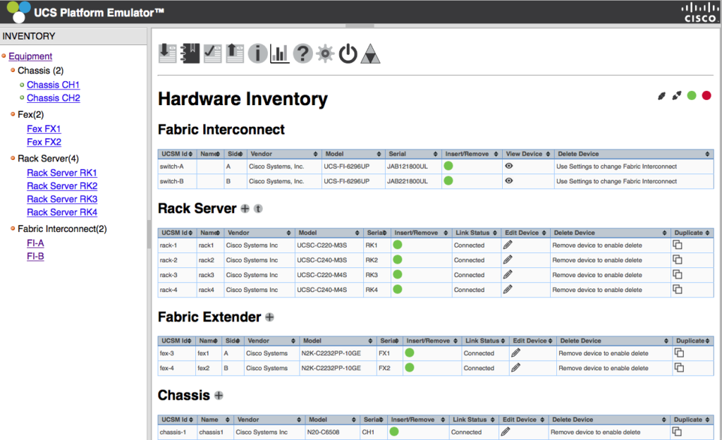
- Removing Equipment
Click the green circle under Insert/Remove. You will see a little box that says “Remove?” , click the Green Checkmark.
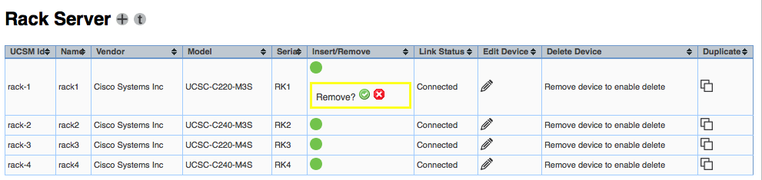
Now you will see the message that your removal has launched successfully.
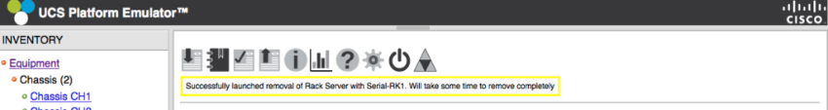
Wait until the green circle changed to red, click the Red X under Delete Device.
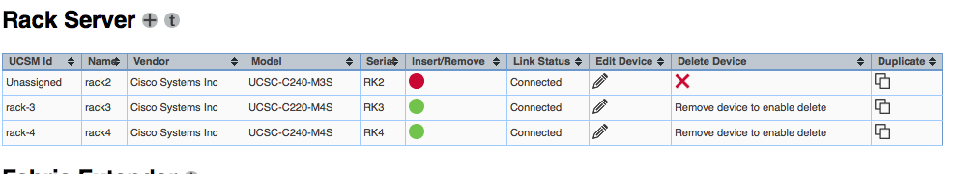
Continue to use this process for everything else you would like to delete in the inventory.
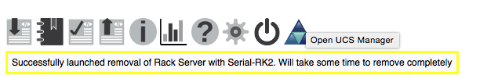
Note, that if you delete a blade chassis, it will also delete all the blade servers in it.
- Adding Equipment
To add something simply click the + button of each hardware type, below picture shows the button for adding Chassis. Enter the name, choose a Chassis model and click "Add" button.
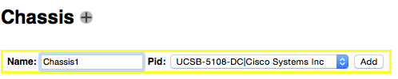
To make a chassis valid, we need to add blades, power supplies, fans, and IO modules. Click the "Edit Device" button,
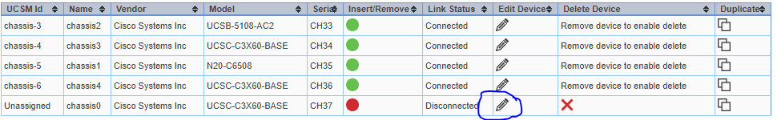
You will enter below page:
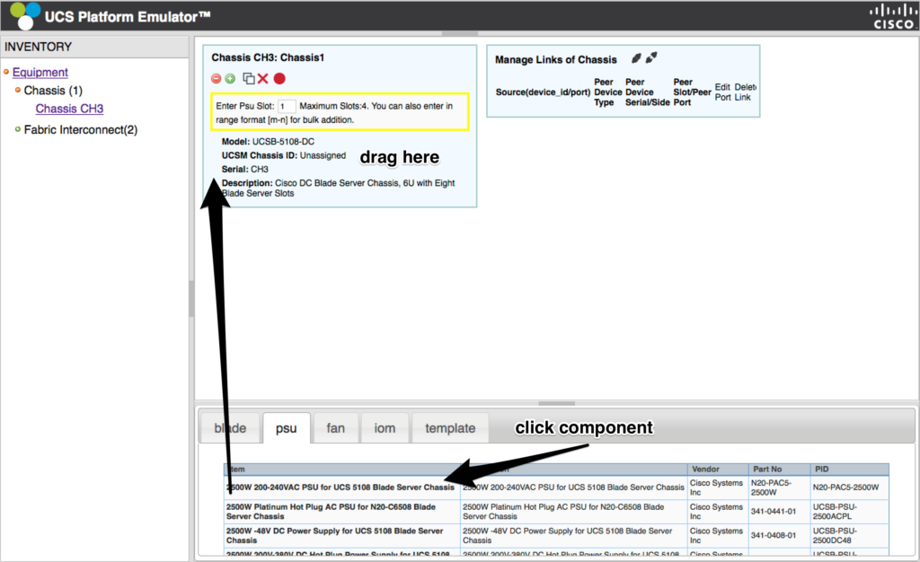

Click the item in the bottom pane and drag it to the Chassis1 pane. Enter the slot you are putting the hardware in (or a range like 1-4 if you want to fill 4 psu slots with the same device) and repeat these steps for all components. You must have appropriate power supplies and fans in the system. For the blades, UCSPE has a number of configuration templates for various servers.
After add all devices, click the Connect button next in the Manage Links of Chassis pane. After everything connected, we can duplicate that chassis if we need multiple ones.
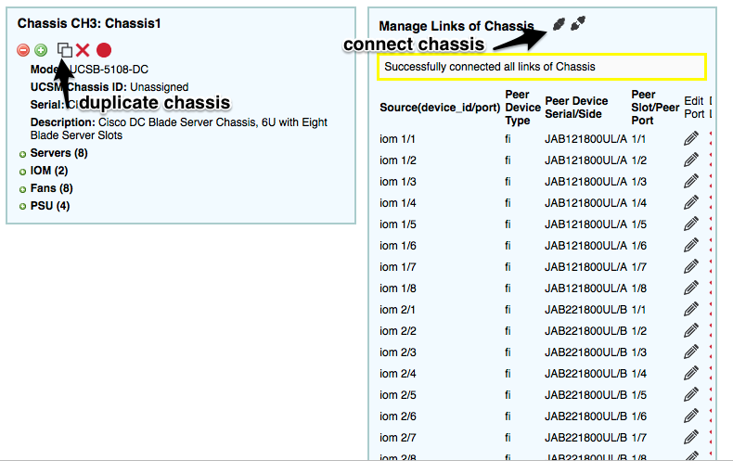
Click connect in the of Hardware Inventory to connect all copied chassis.
Click the red circle under Insert/Remove of each chassis, click the Green Checkbox to insert the chassis. Once Chassis is inserted, all blades to each chassis will be inserted automatically.
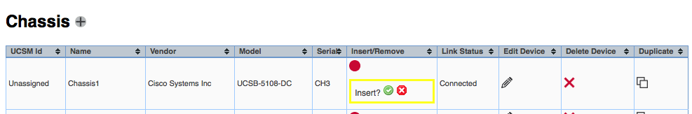

All devices, including Chassis and Blade Server will have green "Insert/Remove" button if insertion is successful, like below.

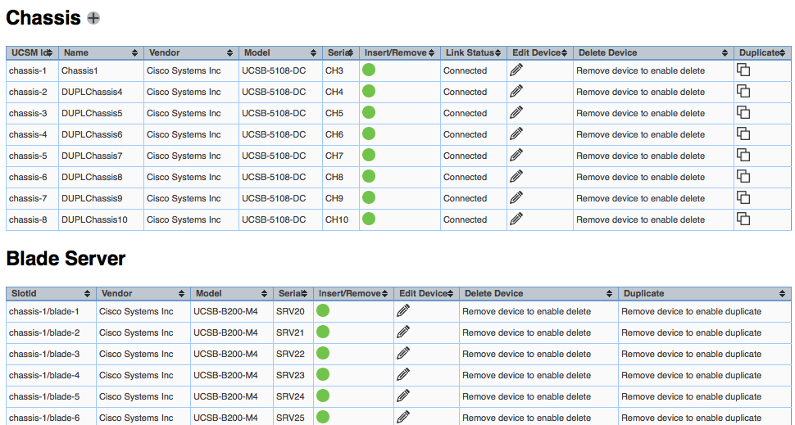
Step 6 Restart UCSPE
To make change effective, we need restart UCSPE.
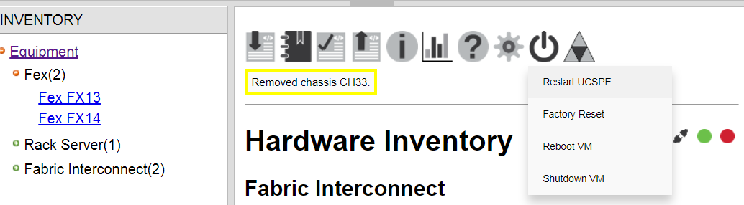
Step 7 Saving and Loading Hardware Configurations
After manual configuration, we can save the virtual hardware configuration. To do this, head back to the UCS Platform Emulator page and click equipment, Click the fourth icon from the left and select Export XML. The XML file will open in a new window. It is suggested to use IE to do the export.

If you want to load an existing UCPSE configuration. You can import it by clicking the first icon on the right and selecting Import from a Saved XML.
Step 8 Launching UCS Manager
Launch UCS Manager by clicking the UCS Manager symbol on the top of the Hardware Inventory pane.
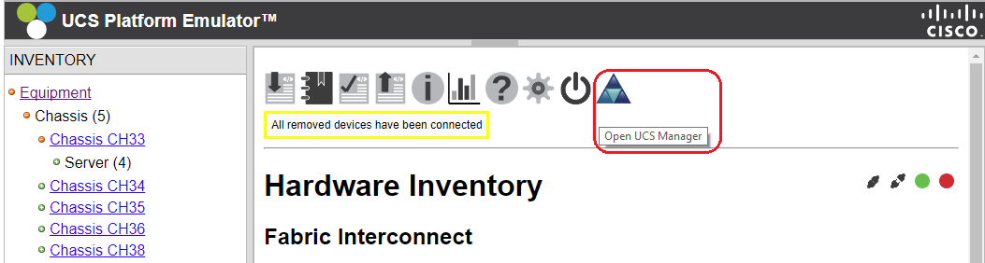

Step 9 Saving the UCS Manager Configuration
Once you restart the VM, or restart the services, your configuration is gone. The emulator does not save the UCS Manager state. Luckily, UCS has backup functionality built right in. Navigate to the Admin tab in the left pane, and you will see Backup Configuration under Actions. Click Backup Configuration, and Create Backup Operation.
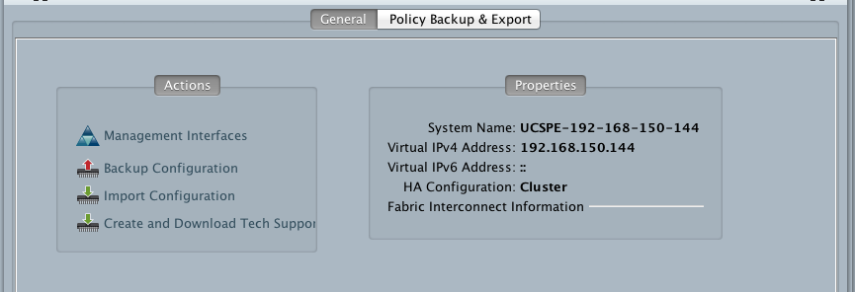
Admin State Enabled means back up right now, so make sure to click the Enabled radio button if you are backing up to a network location. The UCS Emulator Platform does not support Full State backups, so select any of the others. I like to select All Configuration and Preserve Identities. You can back up to a server, or locally. I just back up locally by selecting Location of Backup File as Local File System. Browse to the location you would like to select, and type a file name at the end ending with XML – and no spaces in the name.
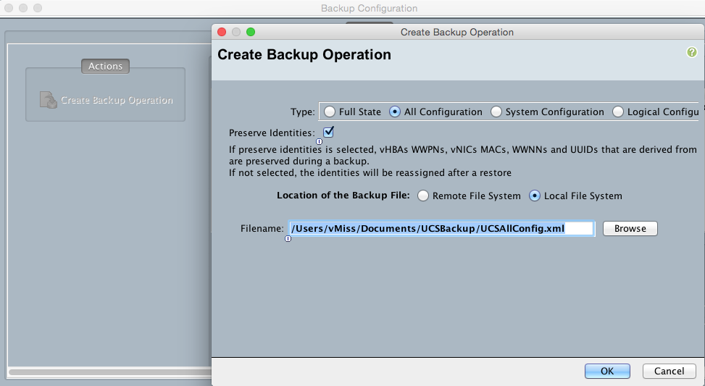
You will get a popup that says your Backup File has successfully downloaded. Save the Port Channels!
Step 10 Importing (Restoring) UCS Manager Configuration
Navigate to the admin tab in the left pane. You will see Import Configuration under Actions. Select Create Import Operation and select your configuration file. As with backing your configuration, Admin State Enabled means do it right now. Then click OK. You will see a message that the configuration has imported successfully and you can pick up where you left off. Your Port Channels are back!
